UNIVERSITY OF PORTHARCOURT

FACULTY OF SCIENCES

DEPARTMENT OF COMPUTER SCIENCE

REPORT OF

STUDENT INDUSTRIAL WORK EXPERIENCE SCHEME (SIWES)

UNDERTAKEN AT BIT-HUB, CHOBA.

BY
ONUCHE SOLOMON|U2014/5570092|DECEMBER 6TH 2017

TABLE OF CONTENT

DEDICATION

This work is dedicated to God Almighty for his protection, provision, wisdom, and divine guidance and sustenance all through my Industrial Training. I dedicate this also to my parents, guardian, pastor, my friends and all my lecturers. You all made the process worth the while.

ii
ACKNOWLEDGEMENT
I will like to acknowledge God first
My family, for their persistence support.
My IT supervisors, Dr. Azubuike I.I, Mr. Lewis Ugege for their guidance and assistance.
To my institution, my H.O.D Dr Onyejegbu, Laeticia Nneka, IT coordinator Mrs. Musa and the entire staff of the Department of Computer Science for their support and directions in my pursuit for a first degree program.

CHAPTER ONE
INTRODUCTION
- OVERVIEW OF SIWES

The student Industrial Work Experience Scheme (SIWES) is a skill training program designed to prepare and expose students of the University to the industrial work situation they are likely to meet after graduation. Experts are of the opinion that there is a yearning gap between the learning acquired by undergraduates and the skills application required in the workplace. Clearly academic learning and theoretical knowledge alone will not bridge the gap that exist between the world of work and the academia. The need for the establishment of the scheme aroused when there was a growing concern among industrialists that graduates of institutions of higher learning lacked adequate practical background required for employment in industries. Thus, the employers were of the opinion that the theoretical education in higher institutions was not responsive enough to the needs of the employers of labour.
In line with the foregoing, SIWES program was designed to complement classroom teaching in the course of studies and to acquaint students with the skills needed in the industries after graduation. The program forms part of the prerequisites for the award of B.Sc. and carries a number of credit units in the University curriculum. The scheme is funded by the Federal Government of Nigeria and jointly coordinated by the National Universities Commission (NUC) and Industrial Training Fund (ITF).
SIWES was established by ITF in 1973 to solve the problem of lack of adequate practical skills preparatory for employment in industries by Nigeria graduates of tertiary institutions.
1.1.2 OBJECTIVES OF SIWES
The aim of the SIWES Directorate is to ensure the proper training of the University students in preparing them for the world of industrial work.
The objectives are:
- To provide an avenue for students in the University to acquire industrial skills and experience in their course of study.
- To prepare students for the work situation they are to meet after graduation.
- To expose students to work methods and techniques in handling equipment and machinery that may not be available in their institutions.
- To make the transition from school to the world of work easier, and enhance students contacts for later job placement.
- To provide students with an opportunity to apply their knowledge in real work situation, there by bridging the gap between theory and practice.
- To enlist and strengthen employers’ involvement in the entire educational process of preparing University graduates for employment in industry.
- To ensure that students in science and technology based disciplines are made to acquire sufficient practical knowledge so that when they get employed on graduation they become immediately productive with little or no further training in their fields of specialization.
- To enable students to pick up skills from the experience and projects of other employees to apply in their own tasks.
- To enable the student, realize their relative strength in a field with many practical applications and help students come out with final year projects that model real life industry challenges.
The unit accomplishes this through the placement of students whom are in their penultimate year in the relevant industrial environments for a minimum of six months.
In collaboration with the Industrial Training Fund, the unit monitors and controls the Industrial Training Program through the use of industry and institution based supervisors, students at the end of the program do present reports on their practical experiences at a departmental interactive forum where faculty members jointly access individual student’s performance on the program as is required by the SIWES curriculum.
The provision of Decree 47 of 8th October, 1971 empowers the ITF to “promote and encourage the acquisition of skills in the industry and commerce with a view to generating a pool of indigenous trained manpower sufficient to meet the needs of the Nigerian economy

1.2
- BRIEF HISTORY OF BITHUB
BitHub is an information technology start-up that was hatched by two purposeful information technology personnel. With their vast experience in developing usable information systems, they came up with the idea of improving the current brain gap between tertiary institutions and the work force in terms of application development technologies. The company is registered with the corporate affairs commission and has overseen several application development and training. Some of our clients include Institute of Petroleum Studies (IPS, University of Port Harcourt), Trinity Communications Ltd (Lagos State), Spinlets Financing Ltd (Port Harcourt), Redeemed Peoples Academy, Jos; to mention but a few. We offer qualitative training with a hands-on approach to learning and a top notch application development experience.

1.3 Organizational Chart

- DEPARTMENTS AND FUNCTIONS
- Mobile App Development: This department is saddled with the responsibility of creating content for the Internship programme on Android App Development and also providing solutions for clients as regards android applications.
- Web Application and Graphics: This department is responsible for building content for the Web Application Internship program on web design technologies like: html, CSS and JavaScript ; database management technology: MySQL, NoSQL, SQLite; backend technologies including: native php (laravel framework) and nodejs. Also gathering information on industry standards and trends on web application development.

CHAPTER TWO
ACTIVITIES DURING SIWES

2.1 INTRODUCTION
In this chapter, the activities carried out during the just concluded industrial training program will be discussed. During the training several packages were on offer among which included, Web designing using HTML, CSS, BOOTSTRAP, MYSQL AND PHP.

2.1.2 INTRODUCTION TO HTML
This is a basic skeletal html page tags
<!doctype html>
<html>
<head>

<meta charset="utf-8">
<title></title>
<meta name="viewport" content="width=device-width, initial-scale=1.0">
<!-- Bootstrap / CSS -->
<link href="css/bootstrap.min.css" rel="stylesheet">
<link href="css/custom.css" rel="stylesheet">
<link href="css/home.css" rel="stylesheet">
<!-- End of css -->
</head>
<body>
<!-- javascript -->
<script src="js/jquery-1.js"></script>
<script src="js/bootstrap.min.js"></script>
<!-- End of css -->
</body>
</html>
HTML stands for HyperText Mark-up Language. It is a mark-up language used to specify the structure a webpage.
Basic Html Tags
- HEADER TAGS
<h1>biggest header ever. </h1>
<h2>next. </h2>
<h3>next next...</h3>
<h4>next next next</h4>
<h5>really small</h5>
<h6>so small </h6>
- TITLE TAG: This is usually written in the head area before the <body> tag, it displays the title of the page in the title area of a browser.
<title>MY IT REPORTT</title>

- PARAGRAPH: This is usually written in the body tag i.e
<body>
<p>Solomon just showing the paragraph tag </br > that is abreak tag too to move to next line. </p>

</body>
- FORMATTING TEXTS: This is used to change the format of whatever text that is used within the webpage.
<p>This paragraph has some fancy <strong>bold</strong>, <em>italic</em>, <u>underlined</u> and <strike>struck through</strike> text. </p>
- UNORDERED LISTS
<p>this are list items without numbering:</p>
<ul>
<li>Garri and Groundnut</li>
<li>eba and egusi</li>
<li>Jollof rice and fried beef</li>
</ul>
- ORDERED LISTS
<p>this one numbers every item in it:</p>
<ol>
<li>java</li>
<li>c++ </li>
<li>c#</li>
</ol>
- IMAGES: This is how to import an image into your webpage.
<img src="domi.jpg" >
- TABLES
<table><table>
<thead>

<tr class="stribbed">

<th>S/No</th>
<th>S. NAME</th>
<th>FIRST NAME</th>
<th>MAT. NO.</th>

</tr>
<tbody>

<tr>
<td>1</td>
<td>ONAH</td>
<td>JOSEPH</td>
<td>U2014/5570051</td>
</tr>

<tr class="stribbed">
<td>2</td>
<td>ORUMA</td>
<td>PHILIP</td>
<td>U2014/5570022</td>
</tr>

<tr>
<td>3</td>
<td>JAMES</td>
<td>PAUL</td>
<td>U2014/5570095</td>
</tr>

<tr class="stribbed">
<td>4</td>
<td>DANIEL</td>
<td>BRAIDE</td>
<td>U2014/5570023</td>
</tr>

<tr>
<td>5</td>
<td>KOFI</td>
<td>BARTELS</td>
<td>U2014/5570067</td>
</tr>

<tr>
<td>1</td>
<td>ONAH</td>
<td>JOSEPH</td>
<td>U2014/5570051</td>
</tr>

<tr class="stribbed">
<td>2</td>
<td>ORUMA</td>
<td>PHILIP</td>
<td>U2014/5570022</td>
</tr>

<tr>
<td>3</td>
<td>JAMES</td>
<td>PAUL</td>
<td>U2014/5570095</td>
</tr>

<tr class="stribbed">
<td>4</td>
<td>DANIEL</td>
<td>BRAIDE</td>
<td>U2014/5570023</td>
</tr>
</tbody>
</table>

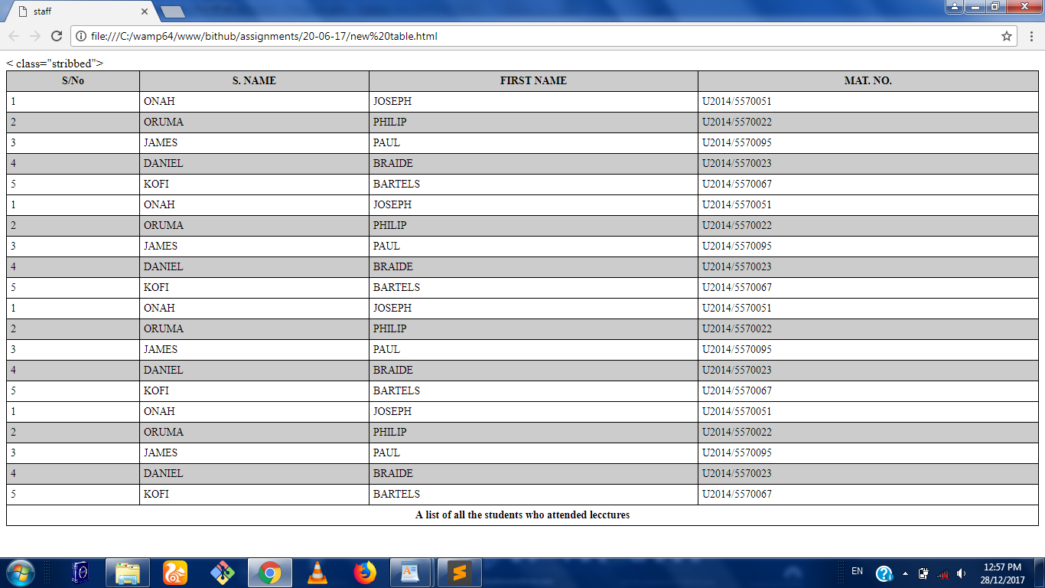fig : a formatted html table

- LINKS: This is used to navigate to other WebPages.
<a href="domi.html">new page</a>

- FORMS: This is used to create forms.
<form>

<p>
<label>Full Name</label>
<input type="text" name="fullNAme" placeholder="Your NAme" required>
</p>

<p>
<label>email</label>
<input type="email" name="email" placeholder="You@email.com" required>
</p>

<p>
<label>password</label>
<input type="password" name="password" required>
</p>

<p>
<label>Your Country</label>
<select>
<option>-Select Country-</option>
<option>NIGERIA</option>
<option>IRAQ</option>
<option>CANADA</option>
<option>LEBANON</option>
<option>IRAN</option>
<option>CHANA</option>
<option>FRANCE</option>
</select>
</p>

<p>
<label>Best Time to Contact You!</label>
<ul>
<li><input type="radio" name="time">Morning </input></li>
<li><input type="radio" name="time">Afternoon </input></li>
<li><input type="radio" name="time" checked=""> Evening</input></li>
</ul>
</p>

<p>
<label>Languages</label>
<ul>
<li><input type="checkbox" name="time">English </input></li>
<li><input type="checkbox" name="time">French </input></li>
<li><input type="checkbox" name="time">Arabic </input></li>
</ul>
</p>

<p>
<p>About You!</p>
<textarea cols="29" rows="5"></textarea>

<p>

<input type="submit" name="signup" value="Click To Signup">
<input type="reset" name="clear" value="clear this form">
</p>
</form>
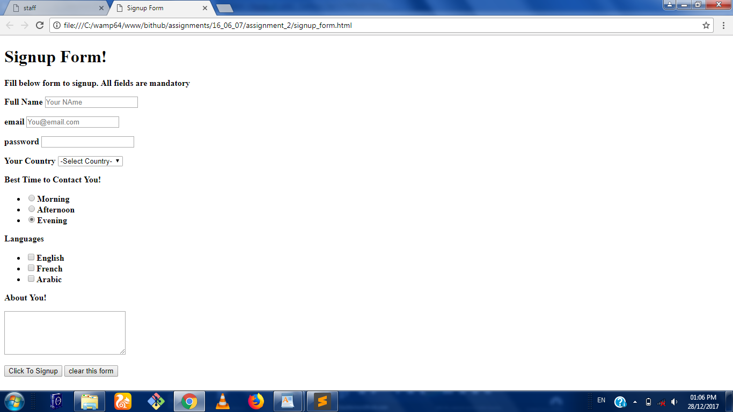
Fig : BASIC HTML FORM

2.2.4 INTRODUCTION TO CSS
CSS is an acronym for cascading style sheet and it file with a list of formatting instructions is a styling language used to style a webpage after the structure has been developed with HTML. CSS is a standard for defining visual presentation of webpages and this concept separates design from content which aids faster download of sites.
The stylesheet(CSS) consists of a number of rules which defines how various webpage elements should be displayed
- Selector rule: This rule specifies which part of the html document the rule will be applied to.
Types of selector
1. Element Selector
td {
color: #0000ff;
front-weight: bold;
}
2. Class Selectors
.warningText {
color: #ff0000;
}

3. ID Selector
#footer {
color: blue;
background: #ccc;
}

4. Group Selector
h1, h2, h3, h4 {
color: green;
}
h1 {
font-size: 1.5em;
color: blue;
}

5. Contextual Selectors
#nav p {
color: blue;
font-weight: bold;
}
6. Pseudo-Selectors
a:hover {
color: red;
}

7. Attribute Selector
#a[href$=‘konsolt.biz’] {
content: url(images/logo.png);
}

- Declaration format: This is basically about the acceptable way of declaring our css. It consists of a number of value/property pairs such as column, background colour, width, border, font size etc.
- It is important to note that the CSS syntax is made up of five parts namely: selector, properties/value, declaration, declaration block and curly braces

There are three ways of inserting CSS style inside an html document
- Inline method
In this method, you write inside the <head> tag.
<html lang =” en”>
<head>
<title> CSS FILE </title>
<metacharset = “utf-8”>
<style>
<p style="color: blue; font-size:200%">
This webpage is for amateur bakers. Registration is free and the good news is that our team will be sending newsletters to you weekly to help develop your baking skills.
</p>
</style>
</head>
- Internal method: It is also written in the head tag.
<html>
<head>
<title>Implementation</title>
<meta charset="utf-8" />
<meta http-equiv="Content-type" content="text/html; charset=utf-8" />
<meta name="viewport" content="width=device-width, initial-scale=1" />
<style>
.large {font-size:200%}
#padded {padding:50px;}

</style>
</head>
<body>
<p class="large">This is some larger text.</p>

<p id="padded">This text has some padding.</p>

</body>

- External method: This method is the most preferred and you either use the import tag or the link tag to reference it which must also be written inside the head tag.
<head>
<title> css implementation</title>
<metacharset = ”utf-8”
<link type = “text/css” rel= ”style sheet” href=” css/style.css”>
</head>

CLASSES AND ID
A class is a name of a certain type of text. An id is a very similar thing with the class the only difference is that the id is used for a single element within a page but classes can be used many times in a page. The convention is that an id can only appear once in a page while a class can appear severally. We use a dot(.) to represent a class and we use hash (#) to represent an id in the CSS styling. If it is an inline styling, it can be written in the head tag but it is always advised to have a separate page for our CSS styling.
Example:
<style type="text/css">

. large {
font-size:200%;
}

#green {
color: green;
}

. underline {
text-decoration: underline;
}
</style>
DIV: The Div tag is just a division of the webpage. Most webpages are divided into two i.e. the header area and the main text area and each of these can be defined by a separate div. Within each div, you can have smaller divs that divides it into smaller sections. A div is just a way to separate your contents into logical sections and to make it easier to keep your contents organized and display the webpage that we want.
Example:
<div class="greenarea">
<p class="large"> I love my brother. </p>
</div>
Other important features of CSS are:
- Colors
- Positioning
- Margins
- Paddings
- Borders
- Fonts
- Styling texts
- Aligning texts
- Styling links

2.2.5 BOOTSTRAP: This is a responsive design frame work with mobile first approach. It uses HTML, CSS and JavaScript.
It is supported by all browsers
The Grid System: Bootstrap ships with four grid systems:
- Extra small devices (xs)
- Horizontal at all times
- <768px
- Small devices (sm)
- >=768px
- Collapses
- Medium devices (md)
- >=992px
- Collapses
- Large Devices (lg)
- >=1200px
- Collapses
Side Bar Styling:
<aside class="col-lg-3 col-sm-4">
<h3><span class="glyphicon glyphicon-list"></span>Menus</h3>
<ul class="nav nav-pills nav-stacked">
<li>
<a href="#">Home</a>
</li>
<li>
<a href="#">Events</a>
</li>
<li>
<a href="#">Contact</a>
</li>

<li>
<a href="logout.php>Logout</a>
</li>
</ul>
</aside>
Column Form Structure:
<article class="col-lg-8">
<form class="form-horizontal" method="post" enctype="multipart/form-data">
<div class="form-group">
<label class="col-sm-3 control-label">DOI:</label>
<div class="col-sm-4">
<input type="text" class="form-control" name ="doi">
</div>
</div>
</form>
</article>

Radio Button Structure:
<div class="form-group">
<label class="col-sm-3 control-label">Gender:</label>
<div class="col-sm-4">
<div>
<label>
<input name="gender" value="Male" type="radio">
<span class="labels"> Male</span>
</label>
</div>
<div>
<label>
<input name="gender" value="Female" type="radio">
<span class="labels"> Female</span>
</label>
</div>
</div>
</div>
Top Nav Bar:
<div class="row">
<nav class="navbar navbar-default navbar-fixed-top navbar-inverse">
<div class="navbar-header">
<button type="button" class="navbar-toggle" data-toggle="collapse" data-target="#collapse">
<span class="sr-only">Toggle navigation</span>
<span class="glyphicon glyphicon-arrow-down"></span>
MENU
</button>
<a class="navbar-brand" href="#"><img src="img/logo1.png" height="30" width="30"/> Kitchen network services</a>
</div>
<div class="collapse navbar-collapse" id="collapse">
<ul class="nav navbar-nav">
<li><a href="project.php">Home</a></li>
<li><a href="#" id="contact.php">Contact</a></li>
<li><a href="#" id ="investments.php">Investments</a></li>
<li><a href="logout.php">Logout</a></li>
</ul>
</div>
</nav>
</div>
Carousel Slider:
<div class="container">
<div id="myCarousel" class="carousel slide" data-ride="carousel" style="width:650px; margin:0 auto">
<ol class="carousel-indicators">
<li data-target="#myCarousel" data-slide-to="0" class="active"></li>
<li data-target="#myCarousel" data-slide-to="1" class="active"></li>
<li data-target="#myCarousel" data-slide-to="2" class="active"></li>
<li data-target="#myCarousel" data-slide-to="3" class="active"></li>
<li data-target="#myCarousel" data-slide-to="4" class="active"></li>
<li data-target="#myCarousel" data-slide-to="5" class="active"></li>
<li data-target="#myCarousel" data-slide-to="6" class="active"></li>
</ol>

<!--slides-->
<div class="carousel-inner" role="listbox">
<div class="item active">
<img src="img/play01.jpg" class="img-responsive img-thumbnail" alt="">
</div>

<div class="item">
<img src="img/play02.jpg" class="img-responsive img-rounded"alt="">
</div>
<div class="item">
<img src="img/play03.jpg" class="img-responsive img-rounded" alt="">
</div>
<div class="item">
<img src="img/play04.jpg" class="img-responsive img-rounded" alt="">
</div>
<div class="item">
<img src="img/play05.jpg"class="img-responsive img-rounded" alt="">
</div>
<div class="item">
<img src="img/play06.jpg" class="img-responsive img-thumbnail" alt="">
</div>
<div class="item active">
<img src="img/play07.jpg" class="img-responsive img-rounded" alt="">
</div>
</div>

<!--left and right controls-->
<a class="left carousel-control" href="#myCarousel" role="button" data-slide="prev">
<span class="glyphicon glyphicon-chevron-left" aria-hidden="true"></span>
<span class="sr-only">Previous</span>
</a>

<a class="right carousel-control" href="#myCarousel" role="button" data-slide="next">
<span class="glyphicon glyphicon-chevron-right" aria-hidden="true"></span>
<span class="sr-only">Next</span>
</a>
</div>

2.2.6 PHP
Php is an acronym for hypertext processor and it was initially developed by RASMUS LEIDORF IN 1994 and was originally used for tracking visits to his online resume. Overtime more functionality was desired and the PHP-tools were rewritten producing a much larger and richer implementation. This new model was capable of database interaction and more, providing a framework upon which users could develop simple dynamic web applications. It is a server-side application. The default syntax is:
<?php
?>
The Short Tag is:
<?
?>
This syntax is used to embed php codes.

COMMENTING CODES IN PHP
1.Single-Line Syntax
//....
2.Shell Syntax
#...
3.Multiple-Line Syntax
/*
...
...
*/
OUTPUTTING DATA ON BROWSER
1.Print () Statement
int print (argument);
print (“... Statement that displays”);
2.Echo Statement
void echo (String arg1[,..., String argN);
echo (“... Statement that displays”);
Echo $var1, “ and “, $var2, “ .”;
Echo “$var1 and $var2 .”;
3.Printf Statement: Ideal for outputing a blend of static text and dynamic information stored within one or more variable.
Example
Int printf (String format [, mixed args]);
printf (“Book cost: %d”, 100);

%d – Integer Value (placeholder = type specifier)
Common type specifiers include:
%f – float;
%s – String;
%u???
%c???
Printf(“%d books at a cost of: %.2f”, 100, 234.4894);
DATA TYPES:
A data type is a generic name for any data sharing a common set of characteristics. The different data types are listed below
- Boolean
- Integer
- Float
- String
- Array

Scalar Data Types
Single valued: boolean, integer, float, string
Compound Data Types:Allows multiple items of same type to be aggregated under a single representative entity.
Array:An Indexed collection of data values.
Object: An object is an entity of a data structure.
VARIABLES: Variables are symbols that can store data and they are named memory location that contains data and may be manipulated throughout the execution of the program.
Variable Declaration: It always begin with a dollar sign ($) followed by the variable name. It may begin with letters or underscore or it may consist of letters, numbers, underscore or ASCII(127-255) and it is case sensitive.
VARIABLE ASSIGNMENT
1.By Value:
$var = 10;
2.By Reference: This is when a variable is referring to the same content of another variable.
$var1 = 1;
Echo $var1;
$var2 =& $var1;
$var2 = 5;
$var2 = &$var1;
VARIABLE SCOPE
Local Variables: They are variables declared in a function and can only be referenced in that function.
<?php
$count = 1;
function increase(){
$count = 5;
$count++;
echo “<br/>Local Variable Count = “.$count.”<br/>”;
}
increase();
echo $count;
?>
Global Variables: They are variables that can be accessed in any part of the program.
In functions,it is important to append “global” to the variable declaration inside the function.
<? php
$count = 1;
function increase(){
global $count;
//GLOBALS[“count”];
$count++;
}
echo $count;

?>
FUNCTION PARAMETERS
Function Parameters comes in the function header. When passed by value, it is no longer accessible when the function is exited. But when passed by reference, it can be accessed even outside.
<?php
$count = 5;
function increase($count){
$count++;
}
increase($count);
echo $count;
?>
STATIC VARIABLES: They still hold value when the function is exited and will still give same value when called upon again. Append “static”
Function keep_track(){
static $count = 0;
$count++;
echo $count.”<br/>”;
}
keep_track();
keep_track();
keep_track();
CONSTANTS: They cannot be modified throughout program execution. The syntax is:
boolean define (String name, mixed value [, Boolean case_insensitive]);
Example:
define ("MAX", 500000);
CONTROL STRUCTURE: It determines the flow of the code within an application, how many times a statement executes (loop) and when a code block relinquishes execution control (condition).
Conditional Statements: These are statements that uses logic to discern between various conditions based on input value.The various types of conditional statements are listed below:
- If statement
- Else statement
- Elseif Statement
- Switch Statement

CONCEPT OF OBJECT ORIENTED PROGRAMING IN PHP:
Php was not fully object oriented until php5 even though php4 embodied some object oriented approach it was still mostly procedural.
Object oriented programming in php represents a major paradigm shift in development strategy.
It focusses on application data rather than its logic.

- CLASS
An embodiment of an entity’s
defining attribute and behaviours.
Real-life items you’d like to
manipulate within an application.

Class Structure is given below:
class className{
//property declaration
//method declaration
}

- PROPERTIES
Similar but different from variables.
They are declared and values assigned at the beginning of the class.
Though php is a loosely “typed” language but it is essential that properties be declared.
public $value = “Lewis”;
NOTE: Public is an access modifier.

- METHODS
Similar to normal functions but are specific to a class or an object.
They are functions that are specifict to a class or object.
They are defined and declared in the class structure usually with access modifiers.

A SIMPLE CLASS DESIGN
class user {
public $firstname;
public $lastname;
public $sex;
public $age;

public get_fullname(){
return $firstname.“ ”.$lastname;
}
}
- OBJECTS
Specific instances of the entity (the class model).
Example
$lewis = new user ();
$lewis->firstname = “Lewis”;
$lewis->lastname = “Thomas”;
echo $lewis->get_fullname();

- OTHER CONCEPTS TOUCHED INCLUDES
1. Encapsulation
2.Inheritance
3.Polymorphism
4.Property Scopes
5.Property Overloading
6.Constructors and Destructors

2.2.7 INTRODUCTION TO MYSQL:
This is the world’s popular open source database. It is a relational database system and it reduces data redundancy and makes viewing and manipulation of data efficient. The model states that data is stored in one or more tables and each table can be viewed as a 2-D matrix consisting of rows and columns. In practice, the rows and columns are referred to as records and fields
Each table is modelled after a real-world entity such as a customer receipt. A column of the table represents attributes of the entity. Row stands as an instance of the entity while a cell which is the intersection of the row and column is used to store a value.
Primary key is the column which uniquely identifies a row in a table(A composite primary key means one or more columns).“Unique Key” is not a primary key but it contains unique values.

SQL:
SQL statements are the same in each dialect.Although SQL is a standard dialect: each vendor has its own (variant).
It is important to note that the most basic SQL statements are the same for every dialect. Examples of other database are ORACLE, DB2, Microsoft SQL Server, MySQL.
Data Manipulation Language

- SELECT
- INSERT
- UPDATE
- DELETE
Data Definition Language

- CREATE DATABASE
- CREATE TABLE
- ALTER TABLE
- DROP DATABASE
- DROP TABLE
Creating database with MYSQL
- Define DB-SERVER (database server)
- Define DB-USER (database user)
- Define DB-PASS (database password)
- Define DB-NAME (database name)
It is important to note that you must open connection, close connection and query the database.

<?php
include_once ('config.php');
class MyPDO {

protected $connection;

function __construct (){
$this->open_connection();
}

protected function open_connection(){
try {
$this->connection = new PDO (DNS,DB_USER,DB_PASS);
} catch (PDOException $e){
echo $e->getMessage();
}
}

protected function close_connection(){
$this->connection = null;
}

}

?>

INSERTING INTO DATABASE
The syntax for inserting into database is
INSERT INTO table_name VALUES (column1, column2, ...);

Example
INSERT INTO `customer`(`customer_id`, `first_name`, `last_name`, `dob`, `email`, `phone`, `address`, `password`, `status`, `next_off_kin`, `created_at`, `modified_at`) VALUES ([value-1],[value-2],[value-3],[value-4],[value-5],[value-6],[value-7],[value-8],[value-9],[value-10],[value-11],[value-12]);

SELECTING FROM DATABASE

The SELECT statement is used to retrieve data from a database. The syntax for SELECT is:
SELECT* column_name, column_name,...
FROM table_name
WHERE conditions;
The WHERE clause can use the comparison operators such as =,!=, <, >, <=,and >=, as well as the BETWEEN and LIKE operators.

Example
SELECT * FROM `customer` WHERE customer_id = 2

UPDATING DATABASE:
The UPDATE statement is used to update data. The syntax for UPDATE is:
UPDATE table_name
SET column_name= value,column_name= value,...
WHERE conditions;
The WHERE clause can use the comparison operators such as =,!=, <, >, <=, and >=,as well as the BETWEEN and LIKE operators.
Example:
The following SQL UPDATE statement changes the age column of the employee whose id is 100:
SQL> UPDATE Employees SET age=20 WHERE id=100;
DELETING DATA FROM THE DATABASE:
The DELETE statement is used to delete data from tables. The syntax for DELETE is:
SQL> DELETE FROM table_name WHERE conditions;
The WHERE clause can use the comparison operators such as =, !=, <, >, <=,and >=, as well as the BETWEEN and LIKE operators.
Example:
The following SQL DELETE statement delete the record of the employee whose id is 100:
SQL> DELETE FROM Employees WHERE id=100;

2.2.8 PROJECT DURING I.T: HOUSE OF OJILE FASHION
House of ojile is a simple web application that is designed to aid the business of a fashion outfit in Lagos own by my elder sister, Mrs Stephanie Amanyi. The website consist of an index page that showcase the outfit latest collections and navigation to other pages, like the gallery page, about us, signup and registration page
- To access the website enter the url: www.houseofojile.com. This will direct you to the home page.
- After that you can enjoy the display of our latest collections and designs on the index page or you can navigate to the gallery and view more categories
- The visitor can signup to the notification services by filling the signup form in the signup page, so he or she can be contacted via email or phone call
- The admin can monitor the activities of visitors to the site
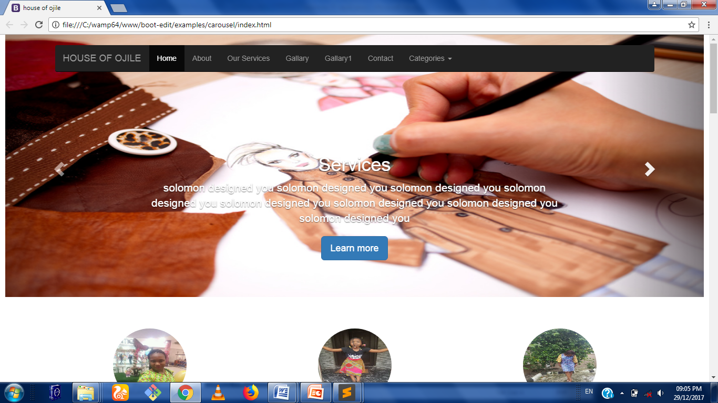
Fig: : Home page

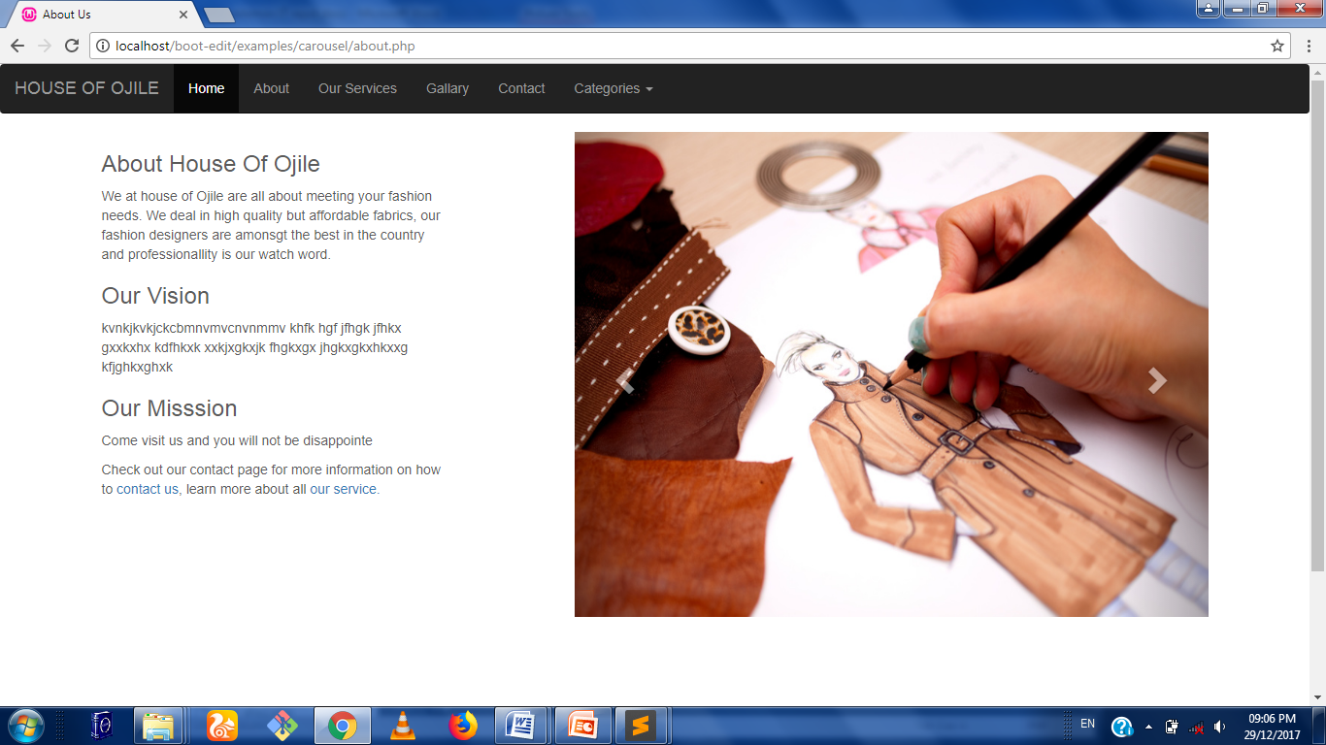
Fig 2: About Us page

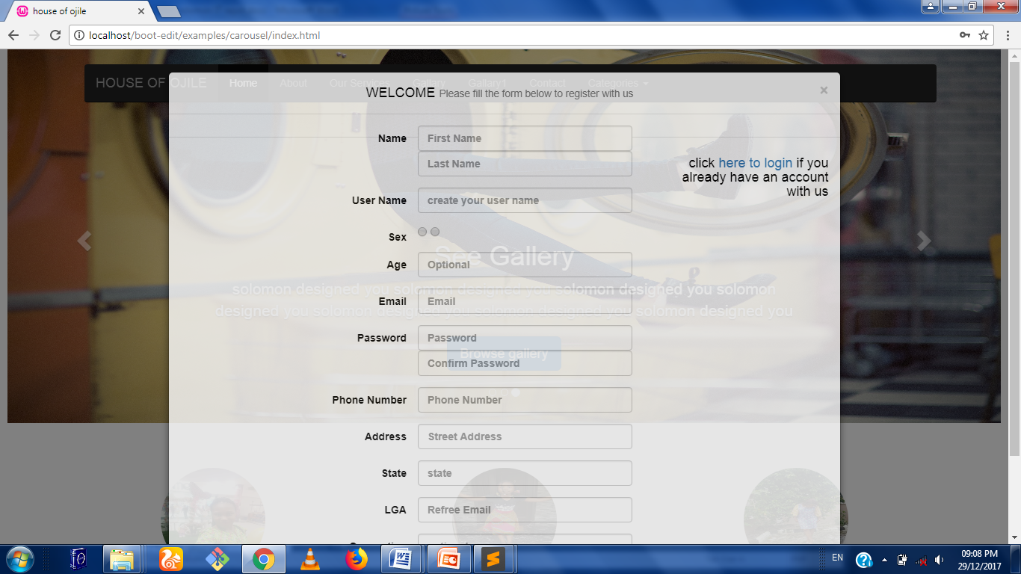
Fig 2: Registration page

CHAPTER THREE
PROBLEMS ENCOUNTERED DURING SIWES
This chapter discusses the challenges I encountered during the just concluded students’ industrial work experience scheme.
The challenges include:
- No allowances from the company.
- Epileptic power supply within choba

Relevance of the SIWES program
The SIWES program is relevant in a number of ways which are detailed below:
- It changes the students’ perspectives about their course of study.
- The disconnection between theory taught in schools and practicalities found in the workforce is bridged.
- It helps broaden the scope of the students in terms of their industrial experience.
SUMMARY
This chapter outlined the challenges faced during the just concluded SIWES program. It also includes the relevance of the SIWES program in our educational curriculum. The discussions in this report also include the training received at BIT-HUB I.T Place.

CHAPTER FOUR
CONCLUSION AND GENERAL APPRAISAL
The Php Programming Languages is an outstanding object oriented language in developing good websites. Its proper understanding is based on the concept of OOP (Object Oriented Programming). Its platform independence also gives it an edge over other OOP (Object Oriented Programming) Languages.
Solving logical problems using a program based orientation is now easy because of the Industrial Training experience. This makes a lot of routine jobs easier because a system can now be written to handle that in a work environment.
Writing solutions to solve problems always taught in school is now understood and can be used. Also, handling projects and appreciating the use of management by using software tools to create work breakdown structure for any project to be started makes ICT a global village.
4.2 WAYS OF IMPROVING SIWES
Every student should be made to undergo the SIWES program regardless of faculty or department differences. The supervisors should endeavor to be at student’s work site for verification and proper assessment and supervision of activities during the industrial training.
This is because some students still do not really understand the whole idea of having a work experience before graduating from school and they feel the time stipulated for the industrial training is for holiday.
I also recommend proper awareness be made known to establishments in Nigeria so that every company would see it as a privilege to have a student attached to them for industrial work experience. This will go a long way to help undergraduates benefit instead of being used for errands.

4.3 ADVISE TO FUTURE PARTICIPANTS
Future participants of the SIWES program should make sure they undergo training, especially in a firm, of their course of study. This is very important because it will arouse the interest of the student to work hard as to achieve the goal of working in that field.
4.4 ADVICE FOR SIWES OFFICIALS
The SIWES program should be enforced in every tertiary institution as it is an avenue for the student’s to obtain relevant industrial skills. SIWES officials should also ensure that the different IT centers are well equipped and have an adequate workforce to help increase the productivity of the Nigerian student.

REFERENCES
BITHUB IT Place tutorial manual.
SIWES Training Log book manual.
Wikipedia

APPENDIX
A
HOME
<!DOCTYPE html>
<html lang="en">
<head>
<meta charset="utf-8">
<meta http-equiv="X-UA-Compatible" content="IE=edge">

<title>house of ojile</title>

<link href="css/bootstrap.min.css" rel="stylesheet">

<!-- IE10 viewport hack for Surface/desktop Windows 8 bug -->
<link href="css/ie10-viewport-bug-workaround.css" rel="stylesheet">

<script src="js/ie-emulation-modes-warning.js"></script>

<!-- HTML5 shim and Respond.js for IE8 support of HTML5 elements and media queries -->
<!--[if lt IE 9]>
<script src="https://oss.maxcdn.com/html5shiv/3.7.3/html5shiv.min.js"></script>
<script src="https://oss.maxcdn.com/respond/1.4.2/respond.min.js"></script>
<![endif]-->

<!-- Custom styles for this template -->
<link href="carousel.css" rel="stylesheet">
<link rel="stylesheet" type="text/css" href="css/modal-css.css">
</head>
<body>
<div class="navbar-wrapper">
<div class="container">

<nav class="navbar navbar-inverse navbar-static-top">
<div class="container">
<div class="navbar-header">
<button type="button" class="navbar-toggle collapsed" data-toggle="collapse" data-target="#navbar" aria-expanded="false" aria-controls="navbar">
<span class="sr-only">Toggle navigation</span>
<span class="icon-bar"></span>
<span class="icon-bar"></span>
<span class="icon-bar"></span>
</button>
<a class="navbar-brand" href="index.html">HOUSE OF OJILE</a>
</div>
<div id="navbar" class="navbar-collapse collapse">
<ul class="nav navbar-nav">
<li class="active"><a href="index.html">Home</a></li>
<li><a href="about.php">About</a></li>
<li><a href="ourservices.php">Our Services</a></li>
<li><a href="gallary.php">Gallary</a></li>
<li><a href="gallary1.php">Gallary1</a></li>
<li><a href="contact.php">Contact</a></li>
<li class="dropdown">
<a href="#" class="dropdown-toggle" data-toggle="dropdown" role="button" aria-haspopup="true" aria-expanded="false">Categories <span class="caret"></span></a>
<ul class="dropdown-menu">
<li><a href="#">Women</a></li>
<li><a href="#">Men</a></li>
<li><a href="#">Children</a></li>
<li role="separator" class="divider"></li>
<li class="dropdown-header">Specials</li>
<li><a href="#">Beads</a></li>
<li><a href="#">T-shirt Branding</a></li>
</ul>
</li>
</ul>
</div>
</div>
</nav>

</div>
</div>

<!--carousel-->
<div id="myCarousel" class="carousel slide" data-ride="carousel">
<!-- Indicators -->
<ol class="carousel-indicators">
<li data-target="#myCarousel" data-slide-to="0" class="active"></li>
<li data-target="#myCarousel" data-slide-to="1"></li>
<li data-target="#myCarousel" data-slide-to="2"></li>
</ol>
<div class="carousel-inner" role="listbox">
<div class="item active">
<img class="first-slide" src="image/service6.png" alt="First slide">
<div class="container">
<div class="carousel-caption">
<h1>Welcome</h1>
<p>solomon designed you solomon designed you solomon designed you solomon designed you solomon designed you solomon designed you solomon designed you solomon designed you</p>
<p><a class="btn btn-lg btn-primary" href="#myModal" data-toggle="modal" role="button">Sign up today</a></p>
</div>
</div>
</div>

<div class="item">
<img class="second-slide" src="image/Fashion-Designer.jpg" alt="Second slide">
<div class="container">
<div class="carousel-caption">
<h1>Services</h1>
<p> solomon designed you solomon designed you solomon designed you solomon designed you solomon designed you solomon designed you solomon designed you solomon designed you</p>
<p><a class="btn btn-lg btn-primary" href="ourservices.php" role="button">Learn more</a></p>
</div>
</div>
</div>
<div class="item">
<img class="third-slide" src="image/slid4.jpg" alt="Third slide">
<div class="container">
<div class="carousel-caption">
<h1>See Gallery</h1>
<p>solomon designed you solomon designed you solomon designed you solomon designed you solomon designed you solomon designed you solomon designed you</p>
<p><a class="btn btn-lg btn-primary" href="gallary.php" role="button">Browse gallery</a></p>
</div>
</div>
</div>
</div>
<a class="left carousel-control" href="#myCarousel" role="button" data-slide="prev">
<span class="glyphicon glyphicon-chevron-left" aria-hidden="true"></span>
<span class="sr-only">Previous</span>
</a>
<a class="right carousel-control" href="#myCarousel" role="button" data-slide="next">
<span class="glyphicon glyphicon-chevron-right" aria-hidden="true"></span>
<span class="sr-only">Next</span>
</a>
</div><!-- /.carousel -->

<div class="container marketing">

<!-- Three columns of text -->
<div class="row">
<div class="col-lg-4">
<img class="img-circle" src="image/boss1.jpg" alt="Generic placeholder image" width="140" height="140">
<h2>Women</h2>
<p>solomon designed you solomon designed you solomon designed you solomon designed you solomon designed you solomon designed you solomon designed you.</p>
<p><a class="btn btn-default" href="#" role="button">View details &raquo;</a></p>
</div><!-- /.col-lg-4 -->
<div class="col-lg-4">
<img class="img-circle" src="image/victoria.jpg" alt="Generic placeholder image" width="140" height="140">
<h2>Children</h2>
<p>solomon designed you solomon designed you solomon designed you solomon designed you solomon designed you solomon designed you solomon designed you</p>
<p><a class="btn btn-default" href="#" role="button">View details &raquo;</a></p>
</div><!-- /.col-lg-4 -->
<div class="col-lg-4">
<img class="img-circle" src="image/eyidown.jpg" alt="Generic placeholder image" width="140" height="140">
<h2>Others</h2>
<p>solomon designed you solomon designed you solomon designed you solomon designed you solomon designed you solomon designed you solomon designed you</p>
<p><a class="btn btn-default" href="#" role="button">View details &raquo;</a></p>
</div><!-- /.col-lg-4 -->
</div><!-- /.row -->

<!-- START THE FEAtures -->

<hr class="featurette-divider">

<div class="row featurette">
<div class="col-md-7">
<h2 class="featurette-heading">Elegant female traditional wear. <span class="text-muted">It'll blow your mind.</span></h2>
<p class="lead">solomon designed you solomon designed you solomon designed you solomon designed you solomon designed you solomon designed you solomon designed you.</p>
</div>
<div class="col-md-5">
<img class="featurette-image img-responsive center-block" data-src="holder.js/500x500/auto" alt="Generic placeholder image" src="image/boss.jpg">
</div>
</div>

<hr class="featurette-divider">

<div class="row featurette">
<div class="col-md-7 col-md-push-5">
<h2 class="featurette-heading">Oh yeah, it's that good. <span class="text-muted">See for yourself.</span></h2>
<p class="lead">solomon designed you solomon designed you solomon designed you solomon designed you solomon designed you solomon designed you solomon designed you</p>
</div>
<div class="col-md-5 col-md-pull-7">
<img class="featurette-image img-responsive center-block" data-src="holder.js/500x500/auto" alt="Generic placeholder image" src="image/slim.jpg">
</div>
</div>

<hr class="featurette-divider">

<div class="row featurette">
<div class="col-md-7">
<h2 class="featurette-heading">Classic Male. <span class="text-muted">Checkmate.</span></h2>
<p class="lead">solomon designed you solomon designed you solomon designed you solomon designed you solomon designed you solomon designed you solomon designed you</p>
</div>
<div class="col-md-5">
<img class="featurette-image img-responsive center-block" data-src="holder.js/500x500/auto" alt="Generic placeholder image" src="image/megatron.jpg">
</div>
</div>

<hr class="featurette-divider">

<!-- /END THE FEATURETTES -->

<!-- FOOTER -->
<footer>
<p class="pull-right"><a href="#">Back to top</a></p>
<p>&copy; 2017 House Of Ojile fashion, Inc. &middot; <a href="#">Privacy</a> &middot; <a href="#">Terms</a></p>
</footer>

</div><!-- /.container -->

<!-- Placed at the end of the document so the pages load faster -->
<script src="https://ajax.googleapis.com/ajax/libs/jquery/1.12.4/jquery.min.js"></script>
<script>window.jQuery || document.write('<script src="../../assets/js/vendor/jquery.min.js"><\/script>')</script>
<script src="js/bootstrap.min.js"></script>

<script src="js/ie10-viewport-bug-workaround.js"></script>

<div id="myModal" class="modal fade">
<div class="modal-dialog modal-lg " >
<div class="modal-content modal-css">
<div class="modal-header">
<button type="button" class="close" data-dismiss="modal" aria-hidden="true">&times;</button>
<h4 class="modal-title">WELCOME <small>Please fill the form below to register with us</small> </h4>
</div>
<div class="modal-body">
<div class="col-lg-offset-2 col-lg-7">

<form class="form-horizontal" method="post" action="signup.php">
<label class="control-label col-lg-4">Name</label>
<div class="form-group col-lg-8">
<input class="form-control" type="text" name="first_name" placeholder="First Name" required=""><input class="form-control" type="text" name="last_name" placeholder="Last Name" required="">
</div>

<label class="control-label col-lg-4">User Name</label>
<div class="form-group col-lg-8"><input class="form-control" type="text" name="user_name" placeholder="create your user name"></div>

<label for="sex" class="control-label col-lg-4">Sex</label>
<div class="form-group col-lg-8">

<input type="radio" name="sex" value="male" >
<input type="radio" name="sex" value="female" >
</div>

<label class="control-label col-lg-4">Age</label>
<div class="form-group col-lg-8"><input class="form-control" type="text" name="age" placeholder="Optional"></div>

<label class="control-label col-lg-4">Email</label>
<div class="form-group col-lg-8"><input class="form-control" type="email" name="email" placeholder="Email" required=""></div>

<label class="control-label col-lg-4">Password</label>
<div class="form-group col-lg-8"><input class="form-control" type="password" name="password" placeholder="Password" required=""><input class="form-control" type="password" name="confirm_password" placeholder="Confirm Password"> </div>

<label class="control-label col-lg-4">Phone Number</label>
<div class="form-group col-lg-8"><input class="form-control" type="tel" name="phone" placeholder="Phone Number" ></div>

<label class="control-label col-lg-4">Address </label>
<div class="form-group col-lg-8"><input class="form-control" type="text" name="address" placeholder="Street Address " ></div>

<label class="control-label col-lg-4">State</label>
<div class="form-group col-lg-8"><input class="form-control" type="text" name="state" placeholder="state"></div>

<label class="control-label col-lg-4">LGA</label>
<div class="form-group col-lg-8"><input class="form-control" type="text" name="local" placeholder="Refree Email"></div>

<label class="control-label col-lg-4">Occupation</label>
<div class="form-group col-lg-8"><input class="form-control" type="text" name="occupation" placeholder="optional"></div>

<button type="submit" name="init" class="btn btn-lg btn-primary col-lg-offset-4 col-lg-4">Sign Up</button>
</form>
</div>

</div>
<div class="modal-footer">
<h4>click <a href="login.php">here to login </a> if you already have an account with us</h4>
</div>
</div>
</div>
</div>

</body>
</html>

SIGNUP LOGIC
<?php
include_once 'includes/customer.php';
include_once 'includes/function.php';

$msg = '';

if(isset($_POST['init'])){
$password = $_POST['password'];
$password1 = $_POST['confirm_password'];
$customer = Customer::instantiate($_POST);
if($customer){
if($password == $password1){
($customer->insertCustomer()) ? redirect('login.php') : $msg = "Failed.";
} else
$msg = "<h1 class='alert alert-warning'>Password mismatch.<h1>";
}
}

?>

<!DOCTYPE html>
<html>
<head>
<link href="../../dist/css/bootstrap.min.css" rel="stylesheet">

<title>registration status</title>
</head>
<body>
<?php echo($msg); ?>
</body>
</html>
CSS
/* GLOBAL STYLES
-------------------------------------------------- */
/* Padding below the footer and lighter body text */

body {
padding-bottom: 40px;
color: #5a5a5a;
background-color:white;
padding-right: 10px;
padding-left: 10px;
}

/* CUSTOMIZE THE NAVBAR
-------------------------------------------------- */

/* Special class on .container surrounding .navbar, used for positioning it into place. */
.navbar-wrapper {
position: absolute;
top: 0;
right: 0;
left: 0;
z-index: 20;
}

/* Flip around the padding for proper display in narrow viewports */
.navbar-wrapper > .container {
padding-right: 0;
padding-left: 0;
}
.navbar-wrapper .navbar {
padding-right: 15px;
padding-left: 15px;
}
.navbar-wrapper .navbar .container {
width: auto;
}

/* CUSTOMIZE THE CAROUSEL
-------------------------------------------------- */

/* Carousel base class */
.carousel {
height: 500px;
margin-bottom: 60px;
}
/* Since positioning the image, we need to help out the caption */
.carousel-caption {
z-index: 10;
}

/* Declare heights because of positioning of img element */
.carousel .item {
height: 500px;
background-color: #777;
}
.carousel-inner > .item > img {
position: absolute;
top: 0;
left: 0;
min-width: 100%;
height: 500px;
}

/* MARKETING CONTENT
-------------------------------------------------- */

/* Center align the text within the three columns below the carousel */
.marketing .col-lg-4 {
margin-bottom: 20px;
text-align: center;
}
.marketing h2 {
font-weight: normal;
}
.marketing .col-lg-4 p {
margin-right: 10px;
margin-left: 10px;
}

/* Featurettes
------------------------- */

.featurette-divider {
margin: 80px 0; /* Space out the Bootstrap <hr> more */
}

/* Thin out the marketing headings */
.featurette-heading {
font-weight: 300;
line-height: 1;
letter-spacing: -1px;
}

/* RESPONSIVE CSS
-------------------------------------------------- */

@media (min-width: 768px) {
/* Navbar positioning foo */
.navbar-wrapper {
margin-top: 20px;
}
.navbar-wrapper .container {
padding-right: 15px;
padding-left: 15px;
}
.navbar-wrapper .navbar {
padding-right: 0;
padding-left: 0;
}

/* The navbar becomes detached from the top, so we round the corners */
.navbar-wrapper .navbar {
border-radius: 4px;
}

/* Bump up size of carousel content */
.carousel-caption p {
margin-bottom: 20px;
font-size: 21px;
line-height: 1.4;
}

.featurette-heading {
font-size: 50px;
}
}

@media (min-width: 992px) {
.featurette-heading {
margin-top: 120px;
}
}
.featurette-image{
width: 500px;
height: 500px;

}
cofig.ph
<?php
defined('DNS') ? null : define ('DNS', 'mysql:host=localhost;dbname=house_of_ojile;charset=utf8');

defined('DB_USER') ? null : define ('DB_USER','root');

defined('DB_PASS') ? null : define ('DB_PASS','');

?>

myPDO.php(database file)

<?php
include_once ('config.php');
class MyPDO {

protected $connection;

function __construct (){
$this->open_connection();
}

protected function open_connection(){
try {
$this->connection = new PDO (DNS,DB_USER,DB_PASS);
} catch (PDOException $e){
echo $e->getMessage();
}
}

protected function close_connection(){
$this->connection = null;
}

}

?>

customer.php(staff class)
<?php
include_once('model.php');
class Customer extends Model{

protected $user_id;
public $user_name;
public $first_name;
public $last_name;
public $sex;
public $local;
public $phone;
public $email;
public $address;
public $age;
public $status;
public $password;
public $state;
public $occupation;

public $error = array();

public static $class_name = 'Customer';
public static $table_name = 'customer';
public static $primary_key = 'user_id';
public static $table_fields = array('user_id','user_name','first_name','last_name','sex','local','phone','email','address','age','status','password','state','occupation');
function __construct()
{
parent::__construct();
}
public function getCustomerId(){
return $this->user_id;
}

public function setCustomerId($user_id){
return $this->user_id = $user_id;
}

public static function authenticate($password, $user_name){
$password = md5($password);
$sql = "SELECT * FROM ".static::$table_name." WHERE user_name = '$user_name' AND password = '$password' LIMIT 1";
echo($sql);
$customer = static::findBySql($sql);
return ($customer) ? array_shift($customer) : false;
}
public function setNewCustomerId(){
if($lastcustomer = static::last()){
$lastId = explode('/', $lastcustomer->user_id);
if (strlen(++$lastId[1])<3){
$this->user_id = 'customer/' .str_repeat('0', 3-strlen($lastId[1])).$lastId[1];
}else{
$this->user_id = 'customer/' .$lastId[1];
}
} else{
$this->user_id = 'customer/001';
}
}

public function insertCustomer(){
$this->setNewCustomerId();
$this->password = md5($this->password);
return ($this->create())? true:false;
}

protected $upload_errors = array (
UPLOAD_ERR_OK => "No errors.",
UPLOAD_ERR_INI_SIZE => "Larger than upload_max_filesize.",
UPLOAD_ERR_FORM_SIZE => "Larger than form MAX_file_size",
UPLOAD_ERR_PARTIAL => "Partial upload",
UPLOAD_ERR_NO_FILE => "No file.",
UPLOAD_ERR_NO_TMP_DIR => "No temporary directory",
UPLOAD_ERR_CANT_WRITE => "Cant write to disk.",
UPLOAD_ERR_EXTENSION => "File upload stopped by extension"
);

public function attach_file($file){
if(!$file || empty($file) || !is_array($file)){

$this->errors[] = "no file was uploaded";
return false;}
elseif ($file['error'] !=0) {
$this->errors[] = $this->upload_errors[$file['error']];
return false;

}

else{
if(!isset($this->staff_id))
$this->setNewStaffId();

$this->temp_path = $file['tmp_name'];
$this->passport = str_replace("/","_", $this->staff_id).".".basename($file["type"]);
$this->type = $file['type'];
$this->size = $file['size'];

return true;
}
}

public function save_with_file(){
if(!empty($this->errors)){
return false;
}
if (empty($this->passport) || empty ($this->temp_path)) {
$this->errors[] = "the file location was not available.";
return false;
}
$target_path = "img/staff/" .$this->passport;

if(move_uploaded_file($this->temp_path, $target_path)){
if(static::find($this->staff_id)){
$this->update();
}else{
$this->password = md5($this->password);
$this->create();
}
unset($this->temp_path);
return true;
}else{
$this->errors[] = "The file upload failed, possible due to incorrect permisions on the upload folder";
return false;
}
}
}
?>
model.php(main class)
<?php
include_once 'myPDO.php';
class Model extends MyPDO{

protected static $class_name;
protected static $primary_key;
protected static $table_name;
protected static $table_fields;

public function __construct(){
parent::__construct();
}

public static function findBySql($sql){
$obj = new static();
$objects = $obj->connection->query($sql)->fetchALL(PDO::FETCH_CLASS,static::$class_name);
return ($objects) ? $objects : false;
}

public static function last(){
$sql = "SELECT * FROM " .static::$table_name. " ORDER BY " .static::$primary_key." DESC LIMIT 1 ";
$obj = new static();
$objects = $obj->connection->query($sql)->fetchAll(PDO::FETCH_CLASS,static::$class_name);

return ($objects) ? array_shift($objects) : false;

}

public static function all(){
$sql ="SELECT * from ".static::$table_name;
$obj = new static();
$objects = $obj->connection->query($sql)->fetchALL(PDO::FETCH_CLASS,static::$class_name);
return ($objects) ? array_shift($objects) : false;
}

public static function find($id){
$sql = "SELECT * FROM " .static::$table_name. " WHERE " .static::$primary_key." = '$id'";
$obj = new static();
$objects = $obj->connection->query($sql)->fetchAll(PDO::FETCH_CLASS,static::$class_name);

return ($objects) ? array_shift($objects) : false;

}

public static function emailLike($email){
$sql = "SELECT * FROM " .static::$table_name. " WHERE email LIKE '%$email%'";
return static::findBySql($sql);
}

public static function instantiate ($record){
$obj = new static();
foreach ($record as $key => $value) {
if(in_array($key, static::$table_fields))
$obj->$key=$value;
}
return $obj;
}

private function attributes(){
$attributes = array();
foreach (static::$table_fields as $field) {
if ($this->$field != Null) {
$attributes[$field] = $this->$field;
}
}
return $attributes;
}

public function create(){
$obj_attributes_array = $this-> attributes();

$obj_attributes_array_keys = array_keys($obj_attributes_array);

$sql = "INSERT INTO ".static::$table_name;
$sql .= " (" .join(',',$obj_attributes_array_keys).")";
$sql .= "VALUES ('" .join("','",$obj_attributes_array)."')";
echo $sql;
return ($this->connection->query($sql)) ? true : false;
}

public function update(){
$sql = "UPDATE ".static::$table_name." SET ";
$attributes = $this->attributes();

$attribute_pairs = array();
foreach ($attributes as $field => $value) {
$attribute_pairs[] = "$field = '$value'";
}
$primary_key = static::$primary_key;
$sql.= join (',', $attribute_pairs);
$sql.= " WHERE $primary_key = '{$this->$primary_key}'";
return $this->connection->query($sql);

}

}
?>

